ShopEZ : E-Commerce Application
Functional Specification & Technical Design Report

INTRODUCTION:
Welcome to ShopEZ – a full-stack MERN (MongoDB, Express.js, React.js, Node.js) e-commerce application designed to provide a simple, convenient, and user-friendly online shopping experience.
ShopEZ allows customers to browse a product catalogue, search and filter products, view product details and reviews, add items to a shopping cart, apply available coupons, and place orders through a streamlined checkout process.
The application provides product images, descriptions, prices, discounts, stock information and ratings in a responsive interface. Customers can register, log in securely, manage their cart, place orders, and view their order history from a single web application.
Secure JWT-based authentication protects customer and administrator accounts, while a dedicated admin area supports product, order and coupon management. The system combines a React frontend with an Express/Node.js REST API and MongoDB database.

SCENARIO Based Case Study:
Background
ShopEZ is an online shopping platform created to make product discovery, purchasing and order management simple for customers while giving administrators tools to manage the catalogue and monitor orders.
Scenario
User Persona:
• Name: Rohan V.
• Age: 21
• Profession: Software Engineer
• Goal: Find products quickly, compare prices and discounts, and complete online purchases conveniently from one application.
• Challenges: Large product choices, difficulty finding relevant products quickly, keeping track of cart items, and managing order information after purchase.
The Challenge
Rohan wanted an online shopping application that was easy to navigate and provided product information, discounts, cart management and order confirmation without requiring him to visit multiple pages or platforms.
• Browse products by category and search for products by name
• View product images, descriptions, prices, discounts and ratings
• Add products to a cart, change quantities and see the subtotal
• Apply coupons and complete checkout while keeping order information organized
Solution: How ShopEZ Helped
When Rohan registers on ShopEZ, he can browse the product catalogue from the home page, search or filter products, open a product detail page, select a quantity and add the item to the cart.
• Product Discovery: Search, category filtering and sorting help customers find products efficiently.
• Cart and Checkout: Customers can review quantities, remove items, apply a valid coupon and place an order.
After placing an order, the application provides order confirmation and stores the order so the customer can review it later from the order history page.

SYSTEM REQUIREMENTS:
To ensure smooth development, deployment, and usage of the ShopEZ web application, certain system prerequisites must be met. These requirements are categorized into software and hardware specifications, all of which contribute to building a robust and scalable trading platform.

1. Software Requirements
These are the essential tools and platforms required to develop, test, and run the application efficiently.
• Operating System: Windows 10/11, macOS, or Linux – supports cross-platform development and testing.
• Node.js (v18 or above): Provides the runtime environment for building and managing frontend logic, and powers the server-side logic and API routing.
• npm (v8 or above): Package manager required to install dependencies for React and related libraries.
• React.js: JavaScript library for building the dynamic, responsive trading UI.
• Browser: Google Chrome / Firefox (latest version) – for rendering and testing the UI in real time.
• Express.js: Lightweight web framework for building the RESTful trading API.
• MongoDB: NoSQL database used to store users, stocks, transactions, and portfolio data.
• Postman: Tool for testing API endpoints during development.
• Visual Studio Code: Preferred code editor with built-in Git and terminal support.

2. Hardware Requirements
Describes the minimum and recommended specifications needed to support development and usage of the application.
• Processor: Intel Core i5 (8th Gen or above) / AMD Ryzen 5 or better – ensures fast compilation and multitasking during development.
• RAM: Minimum 8 GB (16 GB recommended) – for handling development servers, IDEs, and browser testing simultaneously.
• Storage: At least 1 GB free space – required for package installations, MongoDB setup, and local project files.
• Display: 1366x768 or higher – recommended for optimal coding experience and dashboard layout visualization.

TECHNICAL ARCHITECTURE:
User Interface | → | Express Server | → | REST API

Auth Service | → | Product Service | → | Order Service

MongoDB | → | Review/Coupon Service | → | Admin Service

Technical Architecture Overview
The ShopEZ application uses a client-server MERN architecture. The React frontend communicates with the Node.js/Express REST API, while Mongoose provides access to MongoDB for persistent application data.
User Interface (UI):
The React interface provides the home page, product cards, product details, authentication pages, cart, checkout, order history and administrative screens.
Web Server:
The Node.js and Express server receives HTTP requests from the frontend, applies middleware and routes, performs business operations and returns JSON responses.
API Layer:
The REST API exposes endpoints for authentication, products, orders, reviews, coupons and admin operations. Axios on the frontend is used to communicate with these endpoints.
Authentication Service:
Authentication uses user registration and login with bcrypt password hashing and JWT-based authentication. Protected and admin-only routes use authentication middleware.
Product & Catalogue Service:
Product APIs provide product listing, searching, category filtering, sorting and product detail data including price, discount, stock, images and ratings.
Order & Checkout Service:
Order APIs process checkout requests, validate order information and store customer orders. Coupon APIs validate applicable discount codes before an order is placed.
Review & Admin Service:
Review functionality supports product feedback, while admin APIs support management of products, orders and coupons.
Database:
MongoDB stores users, products, orders, reviews and coupons. Mongoose models define the structure used by the backend to read and update these records.
Together, these components provide a complete e-commerce workflow from product discovery and authentication to cart management, checkout, order confirmation and administration.

ER DIAGRAM:

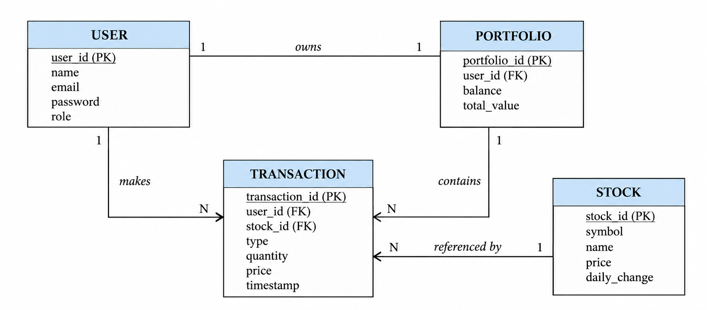

Entities and Relationships
1. User
• Represents customers and administrators using the platform.
• Each user has a unique profile containing name, email, password and role information.
• Relationships:
○ Places → Order: A customer can place multiple orders.
○ Writes → Review: A customer can submit reviews for products.
2. Product
• Represents an item available in the ShopEZ catalogue with name, description, price, category, image, stock and discount information.
• Relationships:
○ Included in → Order: A product can appear in multiple customer orders.
○ Receives → Review: A product can have multiple customer reviews.
3. Order
• Represents a customer's completed purchase containing products, quantities, pricing, discount information and order status.
• Relationships:
○ Belongs to → User: Every order is associated with the customer who placed it.
○ Contains → Product: Each order contains one or more products and quantities.
4. Review
• Represents customer feedback and ratings for products.
• Relationships:
○ Belongs to → User and Product: A review connects a customer with the product being reviewed.

Coupon- Represents a discount code that can be validated during checkout and applied to eligible orders.
Key Features:

1. User Management
• Registration and Authentication: Customers can register and log in securely using JWT-based authentication.

2. Product Catalogue
• Product Browsing: Displays product images, descriptions, categories, prices, discounts, stock and ratings, with search, filtering and sorting.

3. Shopping Cart & Checkout
Cart Management: Customers can add products, change quantities, remove products and review the subtotal.
Coupon & Order Placement: Valid coupons can be applied during checkout and orders can be placed with confirmation.

4. Reviews & Order History
• Customers can view and submit product reviews and access their previous orders.

5. Admin Management
• Admin users can manage products, orders and coupons through protected administrative pages.

ROLES AND RESPONSIBILITIES:
User:-
Registration: Customers can create a ShopEZ account by providing details such as name, email and password.
Product Exploration: Customers can browse products, search by name, filter by category and sort available products.
Product Details: Customers can view product images, descriptions, pricing, discounts, stock and ratings.
Cart Management: Customers can add products to the cart, change quantities and remove items.
Checkout: Customers can validate a coupon, review the order total and place an order.
Order Review: Customers can view their order history and confirmation details.
Reviews: Customers can provide ratings and reviews for products where supported.
Logout: Customers can securely log out of the ShopEZ application.

Admin:-
Product Management: Admins can add, update and remove products from the catalogue.
Order Management: Admins can view and manage customer orders and their status.
Coupon Management: Admins can create and manage discount coupons.
User Access Control: Admin-only operations are protected using authentication and role-based middleware.
Catalogue Monitoring: Admins can maintain product information, pricing, stock and discount details.
Application Maintenance: Admin functionality supports routine management of the e-commerce platform.

User Flow:
Start | → | Login/Signup | → | Home/Catalogue
Search/Filter | → | Product Detail | → | Add to Cart

Cart/Checkout | → | Place Order | → | My Orders

Start → Login/Signup → Home/Product Catalogue
Search/Filter Product → View Product Detail → Add to Cart
Cart Review → Apply Coupon → Checkout
Place Order → Order Confirmation → View Orders → End

Start: The user opens the ShopEZ application.
Login/Signup: The user logs in or registers a new account. Product browsing can also begin from the home page.
Home/Product Catalogue: The user views available products and categories.
Search/Filter Product: The user searches for a product or selects a category and sorting option.
View Product Detail: The user reviews product information, pricing, discount, stock and reviews.
Add to Cart: The user selects a quantity and adds the product to the shopping cart.
Cart Review: The user checks items, quantities and subtotal.
Apply Coupon: The user enters a coupon code and the application validates the discount.
Checkout: The user reviews the final order information and submits the order.
Place Order: The backend creates the order and updates the relevant product stock.
Order Confirmation: The application confirms the successful order.
View Orders: The user can review previous orders from the order history page.
End: The user logs out or exits the ShopEZ application.

MVC PATTERN:
MongoDB | → | Mongoose Model | → | REST Route
User | → | React Frontend | → | API / Database

The ShopEZ application separates data models, backend route handling and the React user interface into distinct responsibilities. This structure provides a clear flow between the frontend, REST API and MongoDB while keeping the application organized and maintainable.

Model Layer
The Model layer consists of MongoDB and Mongoose Models. MongoDB stores the ShopEZ application data, while Mongoose Models define and manage the data stored in the database, including users, products, orders, reviews and coupons.

Controller Layer
The REST Route acts as the connection between the frontend and the database. It receives requests from the React frontend, processes the required operation through the Mongoose Models and sends the appropriate response back to the frontend.

View Layer
The React Frontend provides the user interface of ShopEZ. Users can interact with the application through the frontend to browse products, manage their cart, log in, place orders and view their order information.

Application Flow
The user interacts with the React Frontend. The frontend communicates with the REST Route, which uses the Mongoose Model to access or modify data in MongoDB. The response is then returned through the API to the React frontend and displayed to the user.

Project Setup And Configuration.
• Creating Project Folder
- ○ Create a new folder named ShopEZ.
- ○ Inside it, create Client and Server folders.
- ○ Open the ShopEZ folder in VS Code.
• Client Setup (React)
- ○ Open the Client folder in the terminal.
- ○ Run:
- npm create vite@latest . -- --template react
- ○ Select React → JavaScript.
- ○ Run:
- npm install
- ○ Run:
- npm run dev
• Server Setup (Node.js + Express)
- ○ Open the Server folder in the terminal.
- ○ Run:
- npm init -y
- ○ Create server.js.
- ○ Create folders: models, middleware, routes.
- ○ Run:
- npm run dev

BACKEND DEVELOPMENT:
Backend Reference Video:
https://drive.google.com/file/d/1L2OplsOyztA-O-tIWPShhlm7wpmoNu-h/view?usp=drive_link
Backend Structure
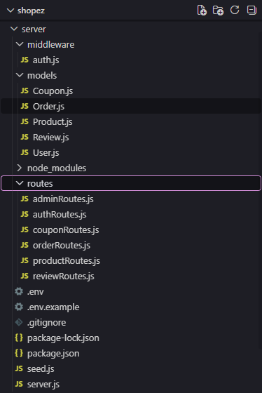

SHOPEZ
└─ Backend/
├─ models/
│ ├─ User.js
│ ├─ Product.js
│ ├─ Order.js
│ ├─ Review.js
│ └─ Coupon.js
├─ middleware/
│ └─ auth.js
├─ routes/
│ ├─ authRoutes.js
│ ├─ productRoutes.js
│ ├─ orderRoutes.js
│ ├─ reviewRoutes.js
│ ├─ couponRoutes.js
│ └─ adminRoutes.js
├─ seed.js
├─ server.js
├─ package.json
└─ .env

Backend/models/
  - User.js – Defines the Mongoose schema/model for customer and administrator accounts.
  - Product.js – Defines the Mongoose schema/model for catalogue products, including price, category, image, stock and discount.
  - Order.js – Defines the Mongoose schema/model for customer purchases, items, quantities, totals and order status.
  - Review.js – Defines the Mongoose schema/model for product ratings and reviews.
  - Coupon.js – Defines the Mongoose schema/model for checkout discount coupons.

middleware/
  - auth.js – Verifies JWT tokens and protects authenticated and admin-only routes.

routes/
  - authRoutes.js – Defines registration and login API routes.
  - productRoutes.js – Defines product listing, searching, filtering, sorting and product detail routes.
  - orderRoutes.js – Defines order creation and customer order routes.
  - reviewRoutes.js – Defines product review routes.
  - couponRoutes.js – Defines coupon validation and coupon-related routes.
  - adminRoutes.js – Defines protected administrator operations for products, orders and coupons.

server.js – Entry point of the backend; sets up the Express server, MongoDB connection, middleware and API routes.

DATABASE DEVELOPMENT:
1. Configure MongoDB:
const mongoose = require('mongoose');
const dotenv = require('dotenv');
dotenv.config();
const connectDB = async () => {
try {
await mongoose.connect(process.env.MONGO_URI);
} catch (error) {
process.exit(1);
}
};
module.exports = connectDB;
• Install Mongoose. In the Node.js server project, run npm install mongoose.
• Create the MongoDB database connection using the MONGO_URI environment variable.
• Create Schemas & Models.
const mongoose = require('mongoose');
const productSchema = new mongoose.Schema({
name: { type: String, required: true },
description: String,
price: { type: Number, required: true },
category: String,
image: String,
stock: { type: Number, default: 0 },
discountPercent: { type: Number, default: 0 }
});
module.exports = mongoose.model('Product', productSchema);

Create Database connection:
const mongoose = require('mongoose');
const userSchema = new mongoose.Schema({
name: String,
email: { type: String, unique: true },
password: String,
role: { type: String, enum: ['USER', 'ADMIN'], default: 'USER' }
});
module.exports = mongoose.model('User', userSchema);
The backend connects to MongoDB through Mongoose before performing product, user, order, review or coupon operations. The connection string is stored in the environment configuration.
Create Schemas:
The MongoDB collections are represented through Mongoose schemas. The main models are User, Product, Order, Review and Coupon. These schemas provide a consistent structure for application data.
Product.js – Defines the Mongoose schema/model for products stored in the database, including name, description, price, category, image URL, stock and discount.
User.js – Defines the Mongoose schema/model for customer and administrator accounts, including name, email, password and role.

FRONT-END DEVELOPMENT:
Frontend Reference Video:
https://drive.google.com/file/d/1kknCl4fMyajr4ljQenZLWi4_QZcQCIV6/view?usp=drive_link
Frontend Structure:

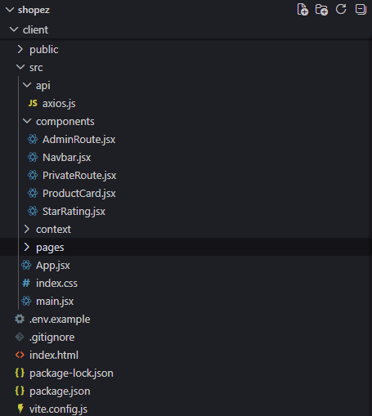

Frontend/
└─ src/
├─ components/
│ ├─ Navbar.jsx
│ ├─ ProductCard.jsx
│ ├─ PrivateRoute.jsx
│ ├─ AdminRoute.jsx
│ └─ StarRating.jsx
├─ context/
│ ├─ AuthContext.jsx
│ └─ CartContext.jsx
├─ pages/
│ ├─ Home.jsx
│ ├─ ProductDetail.jsx
│ ├─ Login.jsx
│ ├─ Register.jsx
│ ├─ Cart.jsx
│ ├─ Checkout.jsx
│ └─ MyOrders.jsx
├─ api/
│ └─ axios.js
├─ App.jsx
├─ main.jsx
└─ index.css

Frontend/src/components/
• Navbar.jsx – Provides the main navigation bar and displays the shopping cart count.
• ProductCard.jsx – Displays product image, price, discount, rating and product actions.
• PrivateRoute.jsx – Protects routes that require a logged-in user.
• AdminRoute.jsx – Protects routes that require administrator access.
• StarRating.jsx – Displays product ratings.
Frontend/src/context/
• AuthContext.jsx – Provides global authentication state and login, registration and logout functions.
• CartContext.jsx – Stores cart items and provides add, update, remove and subtotal operations.
Frontend/src/pages/
• Home.jsx – Displays the product catalogue with search, category filtering and sorting.
• ProductDetail.jsx – Displays detailed product information, stock, rating, reviews and add-to-cart controls.
• Login.jsx – Provides the user login form and authentication flow.
• Register.jsx – Provides the account registration form.
• Cart.jsx – Displays cart items, quantities, subtotal and checkout navigation.
• Checkout.jsx – Validates coupon information and places orders.
• MyOrders.jsx – Displays the logged-in user’s previous orders.
• Admin Pages – Provide protected screens for product, order and coupon management.
Frontend Root Files/
• App.jsx – Main component that defines application routes and page layout.
• index.css – Global stylesheet applied across the React project.
• main.jsx – Entry point that renders the App component into the DOM.
Frontend/src/api/
• axios.js – Configures the Axios client used for backend API communication.

Output ScreenShots:

Landing Page:
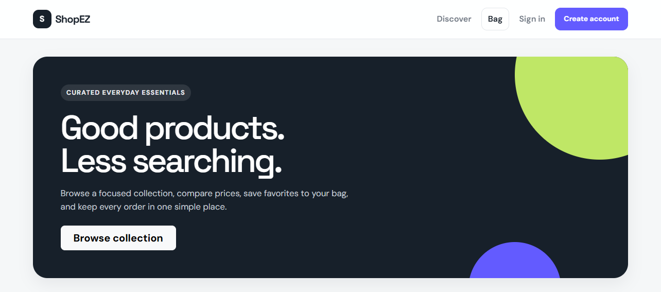

Signup Page:
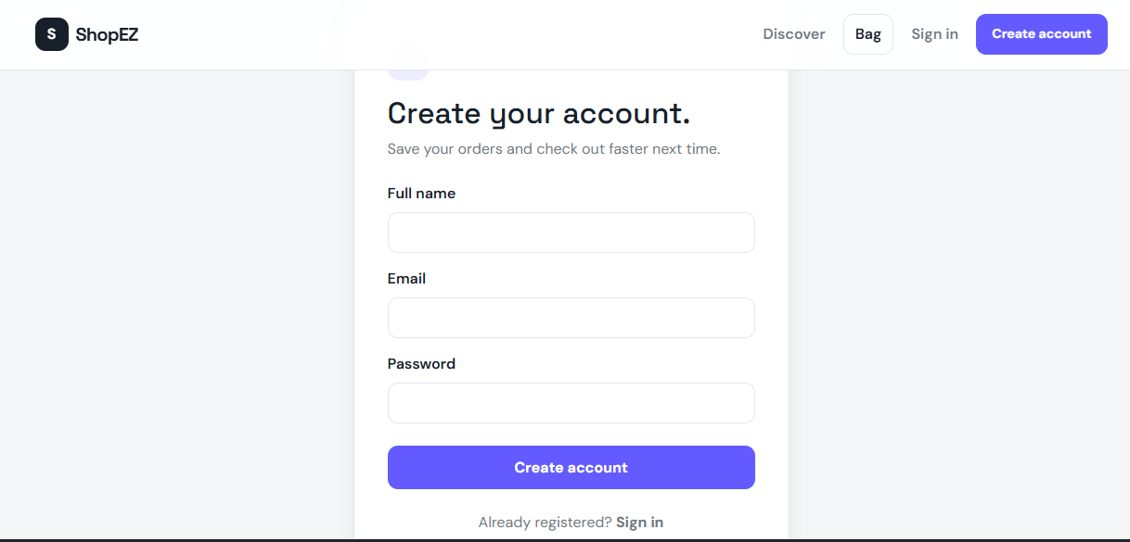

Login Page:
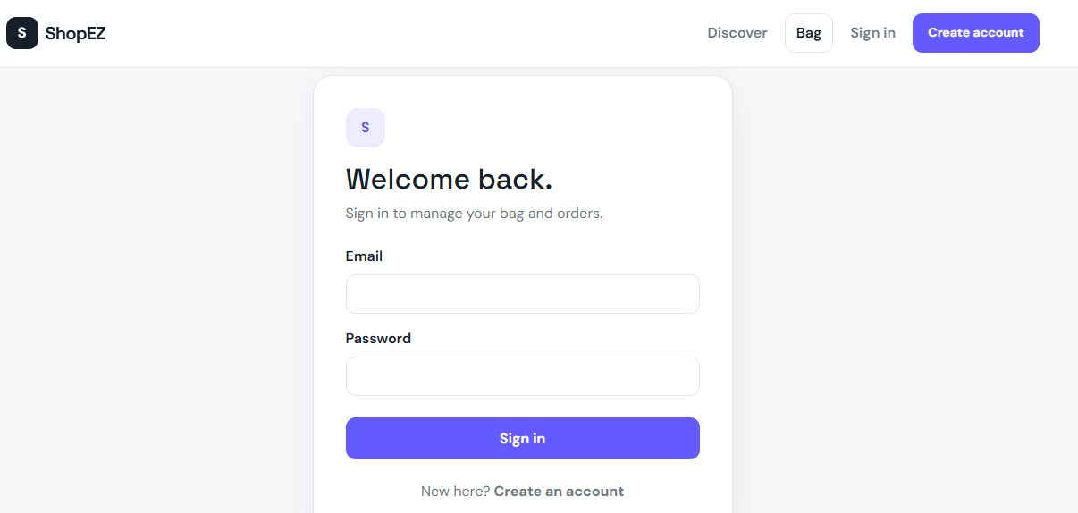
Dashboard:
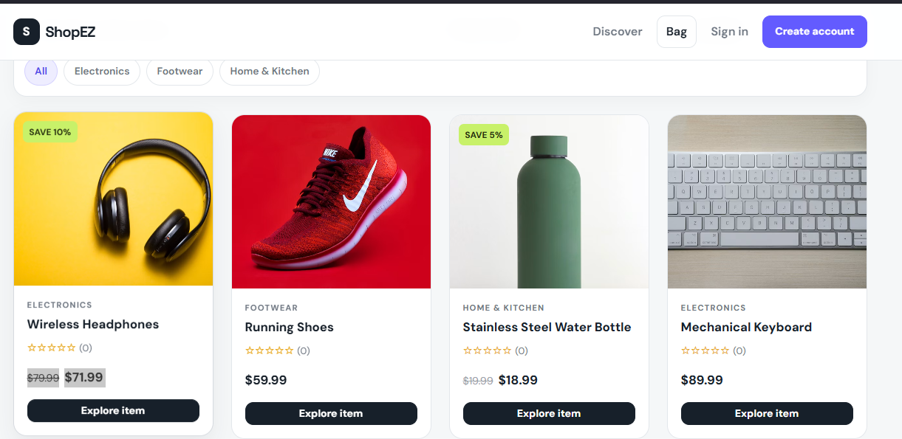
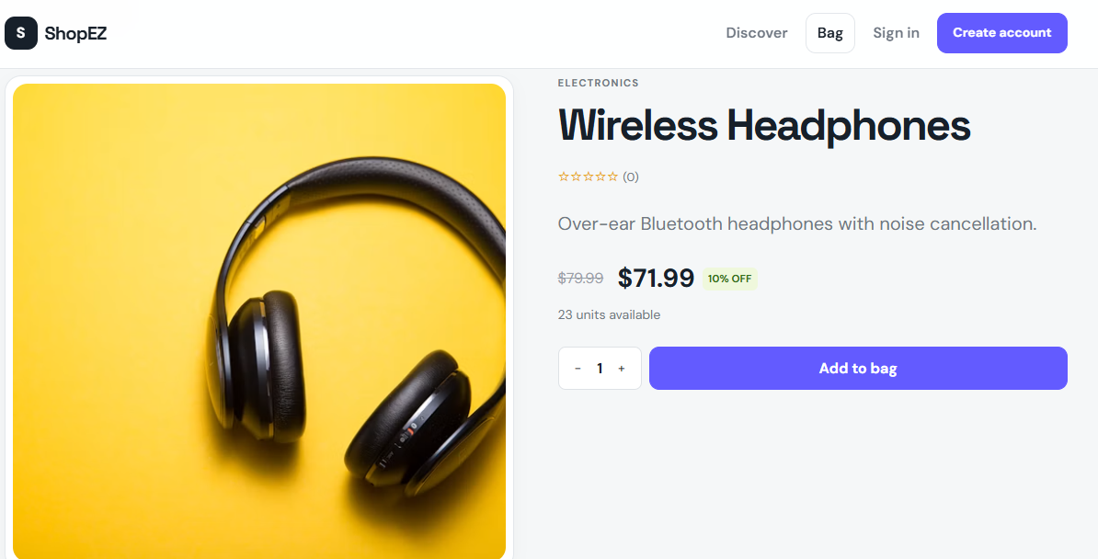
Cart page:
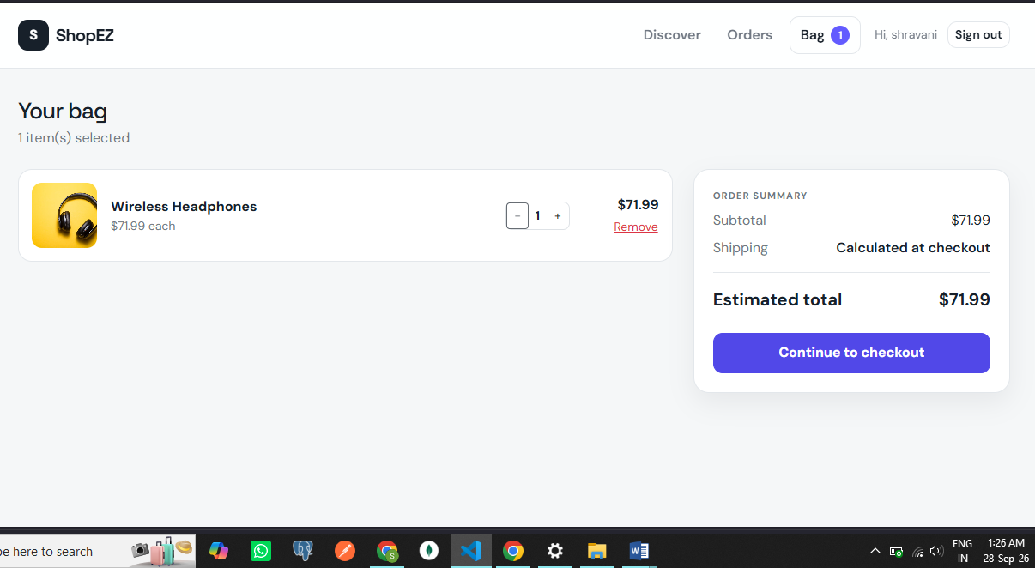

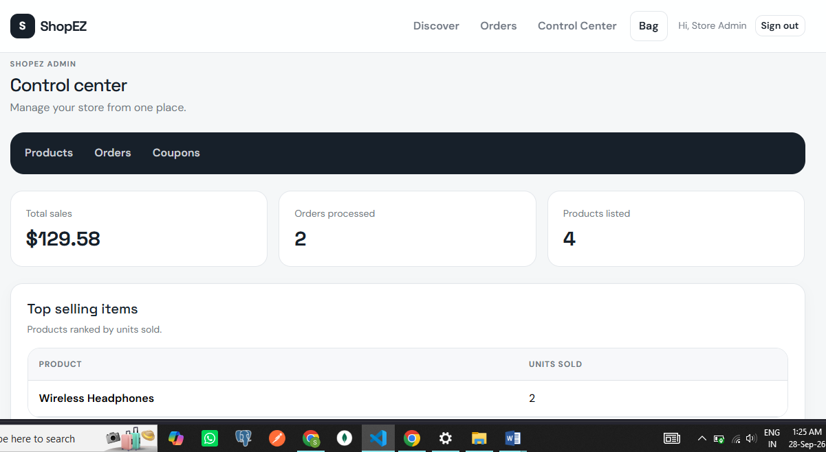
Admin dashboard:

